**A CRM Application to Handle The Clients And Their Property Related Requirements**

**Email**: 6369533122shyam@gmail.com

**Name: SHYAM SUNDER V**

# Team members: Suthish Kumar M , Thirukumaran C , Viswa B

**1. Project Overview**

# The Nanmudhalvan CRM Project is a comprehensive Customer Relationship Management (CRM) application designed to manage clients and their property-related requirements efficiently. This overview outlines the primary objects (classes) within the system, their attributes, methods, and the relationships between them. This object-oriented approach ensures scalability, maintainability, and seamless integration of various functionalities essential for real estate management.

# 2. Objectives

* **Business Goals:** 
  + 1. Attract new clients by offering a streamlined, efficient CRM experience tailored to their real estate needs.
    2. Improve client satisfaction and loyalty by delivering personalized service, which leads to increased client retention and repeat business.Improve operational efficiency for admissions and administrative staff, reducing processing time and enhancing student experience.
* **Specific Outcomes:** 
  1. Achieve a measurable increase in client satisfaction scores through personalized service, quicker response times, and streamlined communication.

Improve client engagement by providing a tailored experience that addresses each client's unique property needs and preferences.Enable automated email notifications and generate reports to track application metrics, acceptance rates, and enrollment trends.

* 1. Develop a CRM system that can accommodate an expanding client base, property listings, and new agents with
  2. Reduce the time properties spend unlisted or unsold, optimizing property utilization and boosting revenue from quicker transactions.
  3. Generate detailed reports on market trends, popular property features, and client preferences, helping management adjust offerings and strategies based on real demand.

1. **Salesforce Key Features and Concepts Utilized**

**. Objects and Data Modeling**:

Custom objects were created to manage critical data, including client information, property listings, and specific client requirements. This structured data modeling allows for efficient organization and retrieval of information essential for managing real estate transactions.

* + **Process Builder and Automation**:

Workflows were set up to automate property recommendations based on client requirements, notifications for new listings or deals, and updates on the status of deals.

* + **Approval Processes**:

Approval workflows for new property listings and deals were implemented to ensure listings meet company standards and that all deals are reviewed before finalization.

* + **Email Alerts and Notifications**:

Email notifications were created for critical actions, such as new property listings, deal status changes, and client engagement follow-ups. These alerts ensure clients and agents receive timely updates, improving communication and keeping all stakeholders informed.

* + **Reports and Dashboards**:

Custom reports and dashboards offer insights into client preferences, property availability, and deal closure rates. These analytics empower management and agents to make data-driven decisions, improving targeting, identifying popular property types, and monitoring deal progression.

* + **Appointment Scheduling**:

The built-in scheduling feature allows agents to set up property viewings and consultations with clients, tracking appointment dates, times, and purposes directly within the CRM.

* + **Case Management for Immigration**:

Salesforce’s case management functionalities were leveraged to track and update client inquiries and property requests. Document management and collaboration tools are used for seamless communication and documentation of each client’s requirements and deal status.

1. **Detailed Steps to Solution Design**

1. **Create Objects from Spreadsheet**

* + - * **Create Customer object**
      * **Create Property object**

**. Create Custom Object**

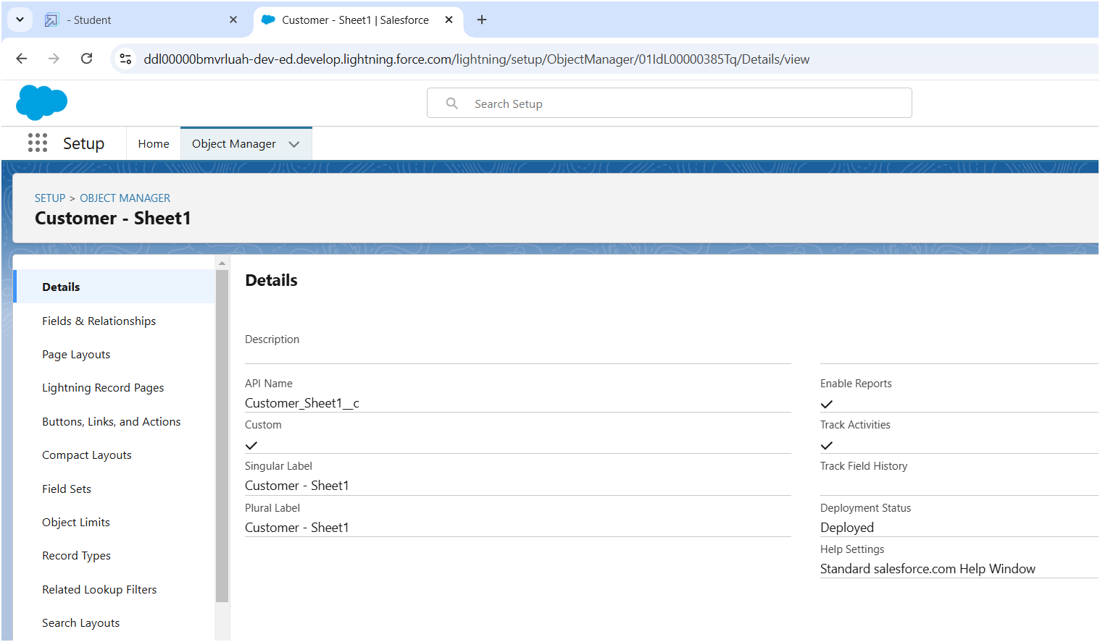

**. Create Property Object**

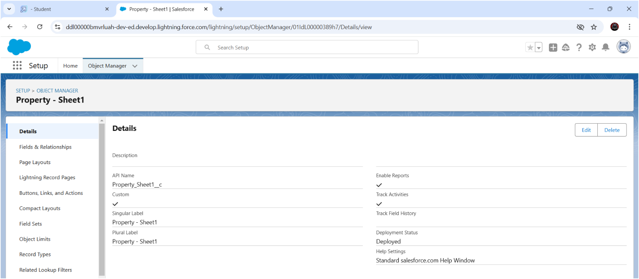

**. Integrate salesforce platform**

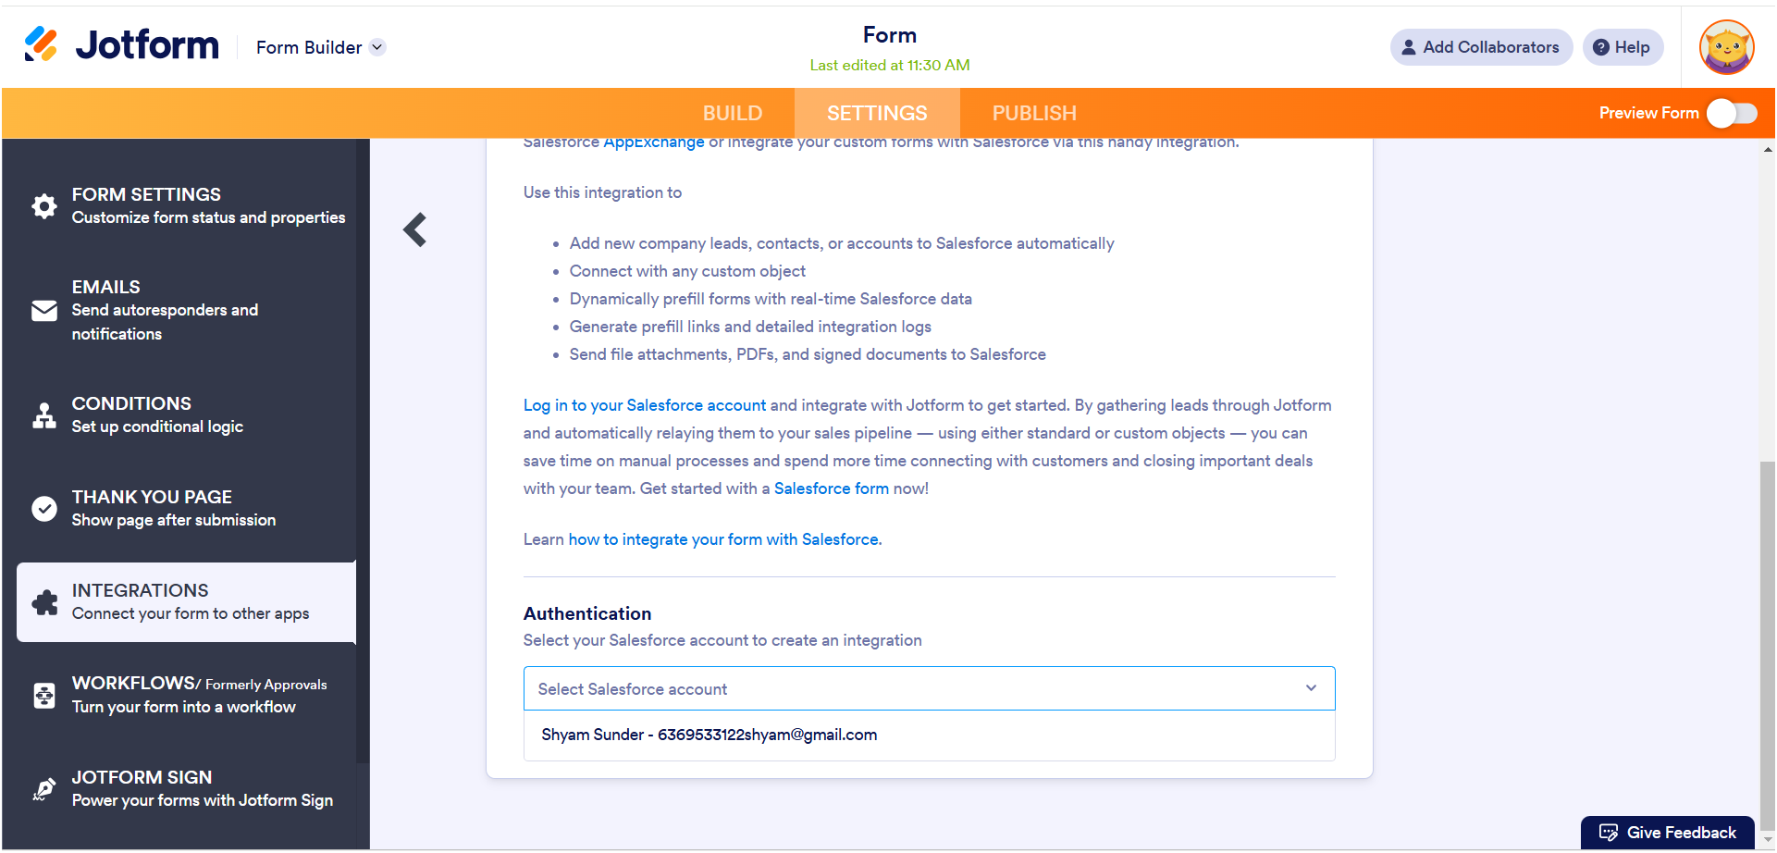

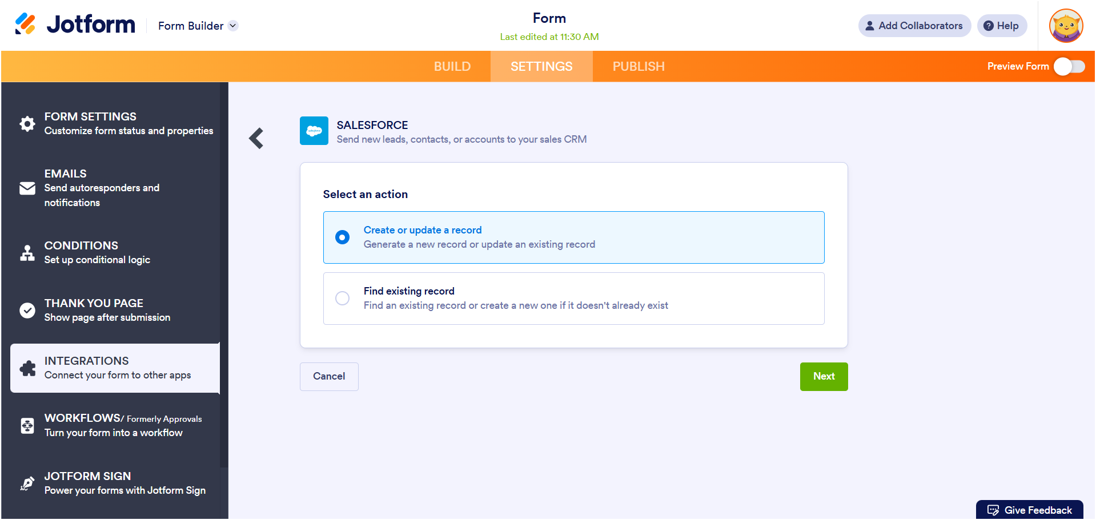

**. Create Profiles**

**. Customer**

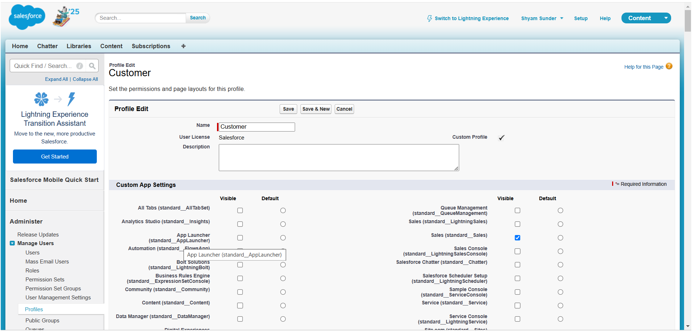

**. Manager**

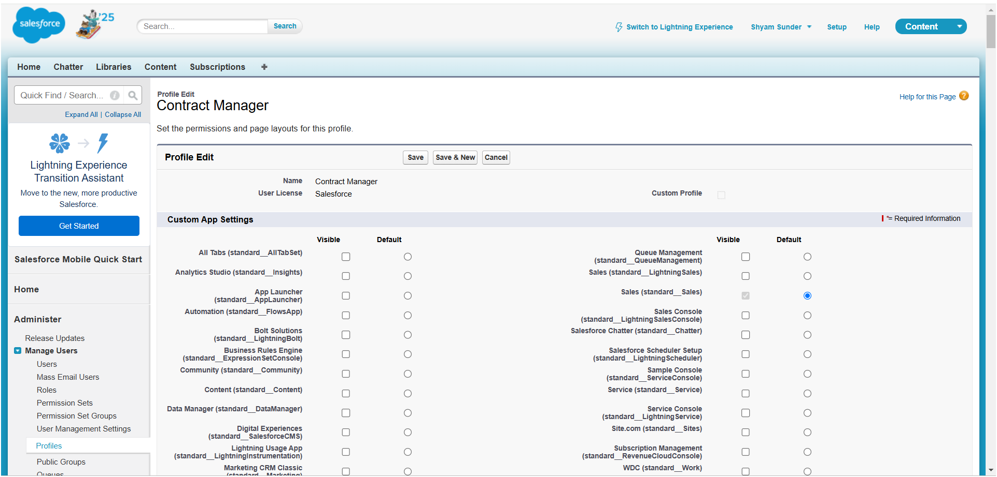

# . Create Users

**. user 1**

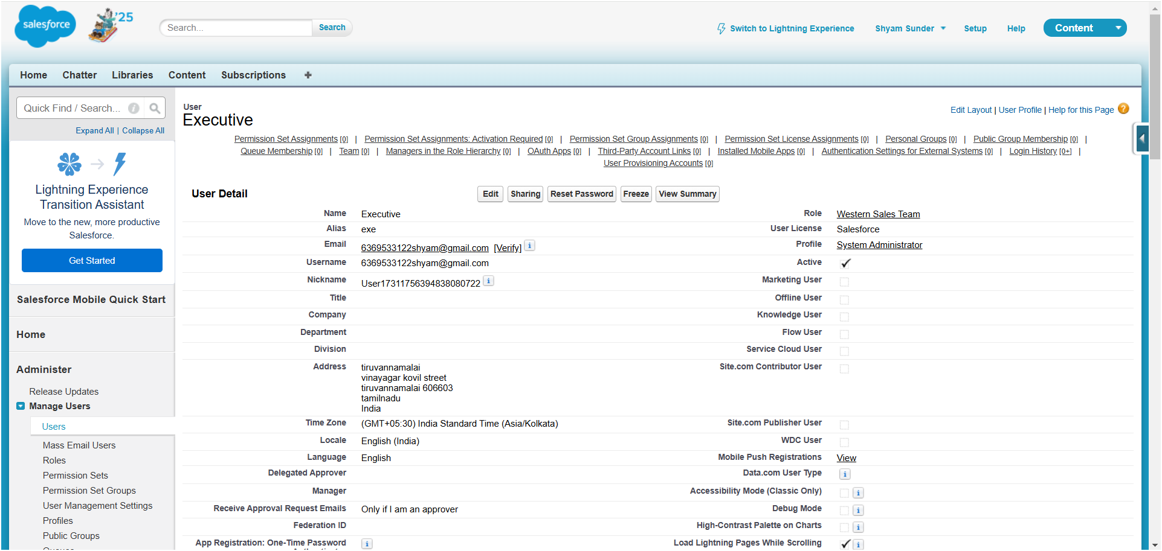

**. User 2**

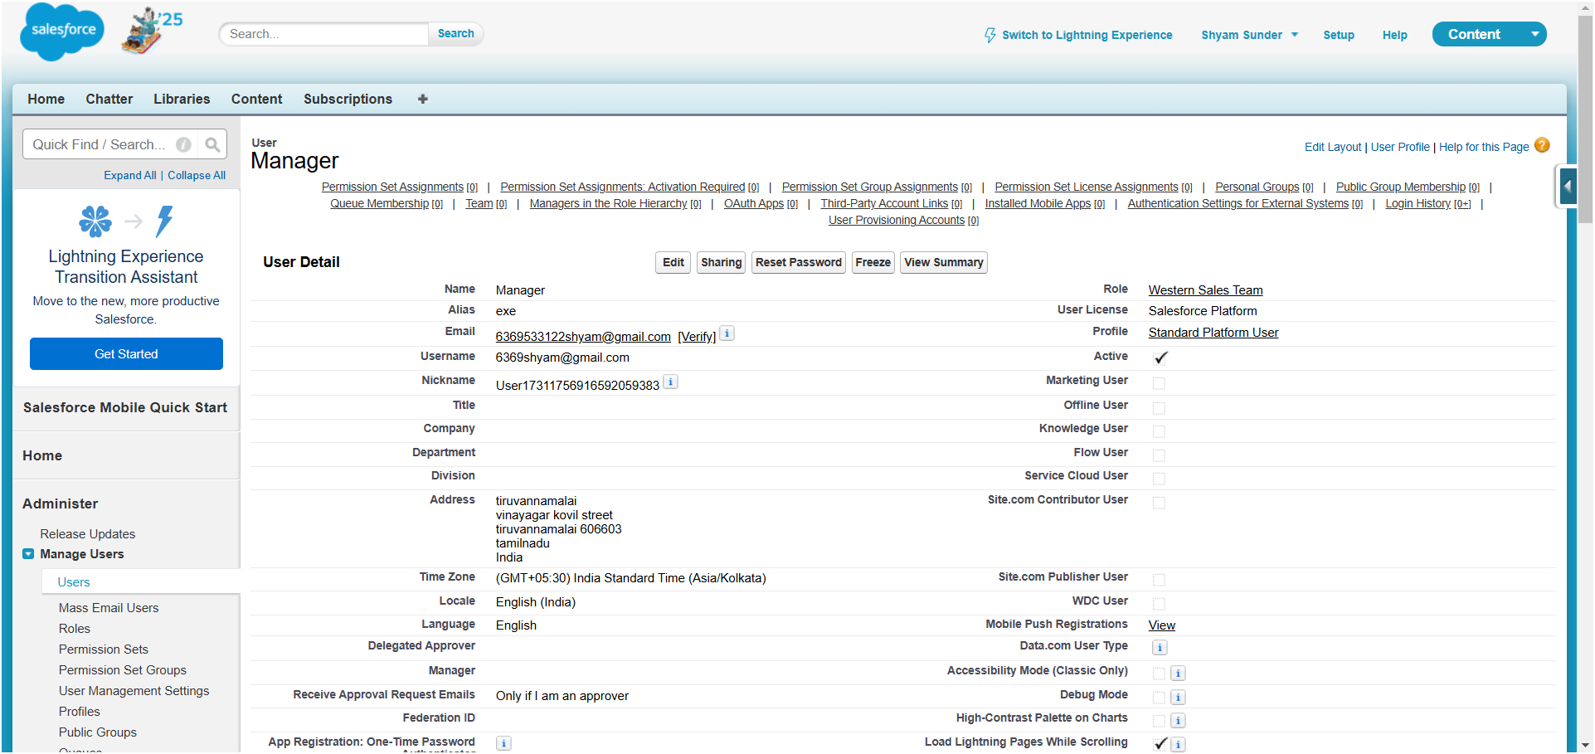

**. User 3**

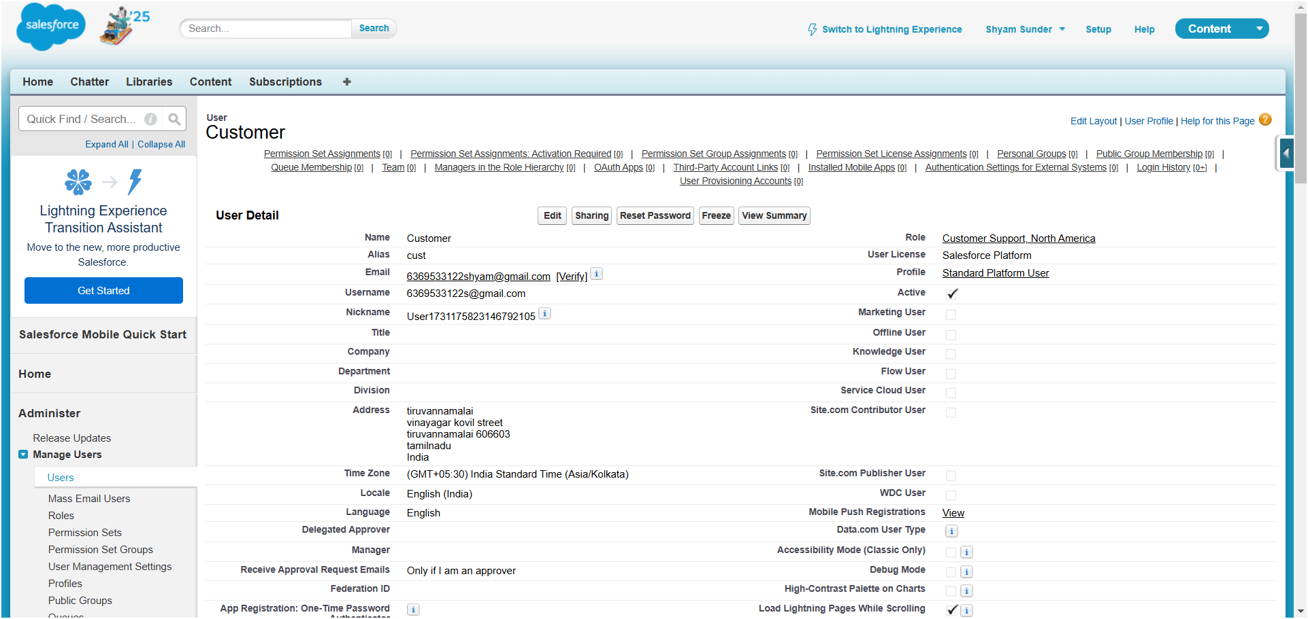

**. User 4**

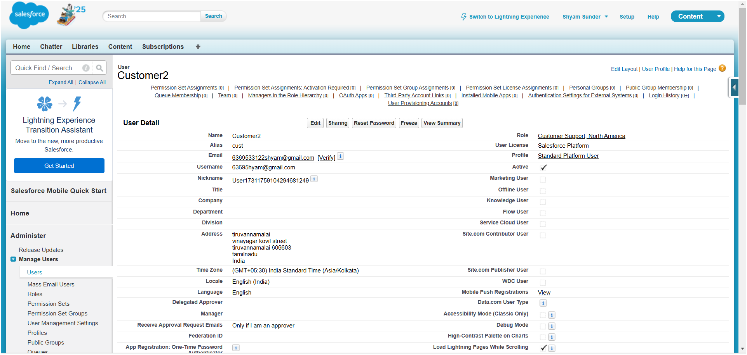

**Creating an jotform and integrate with org**

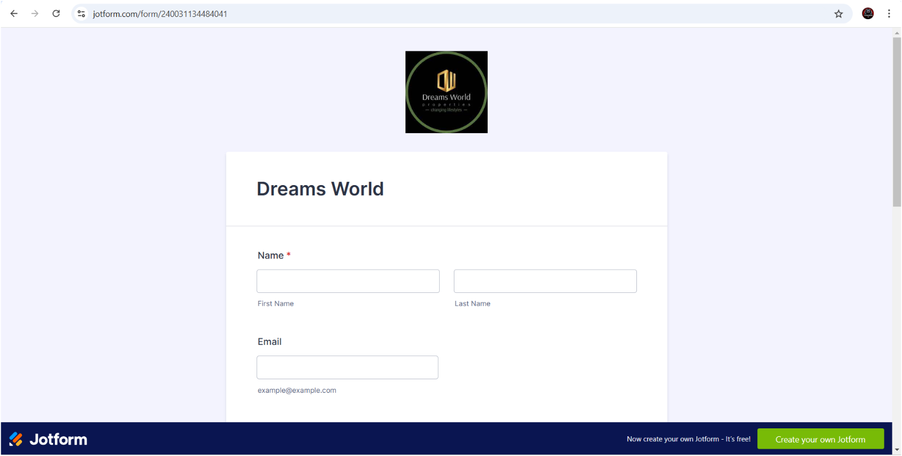

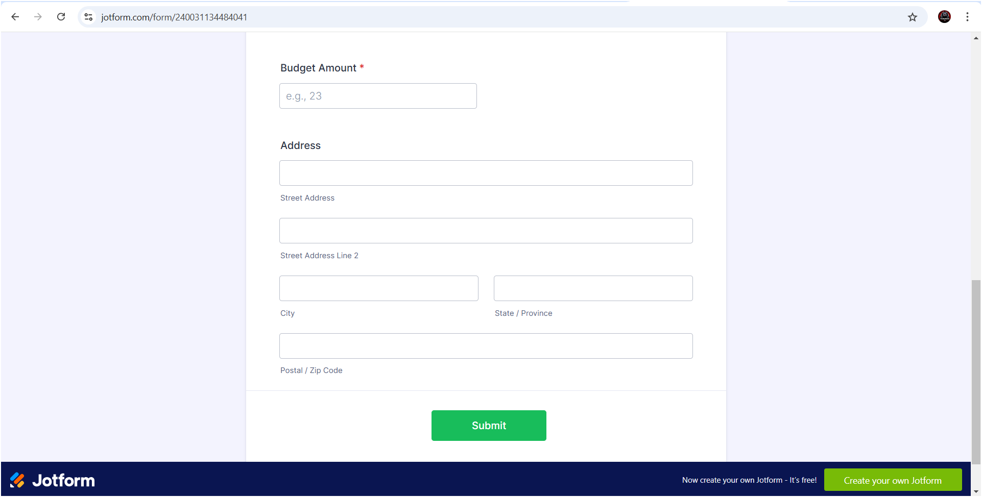

**Creating an App Page**

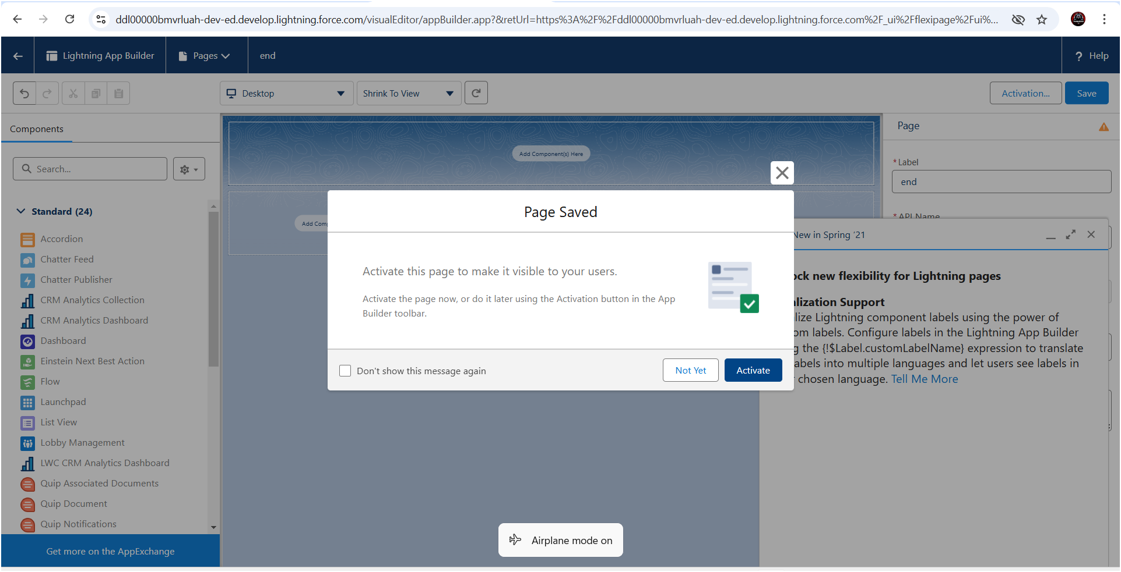

**Create A LWC Component**

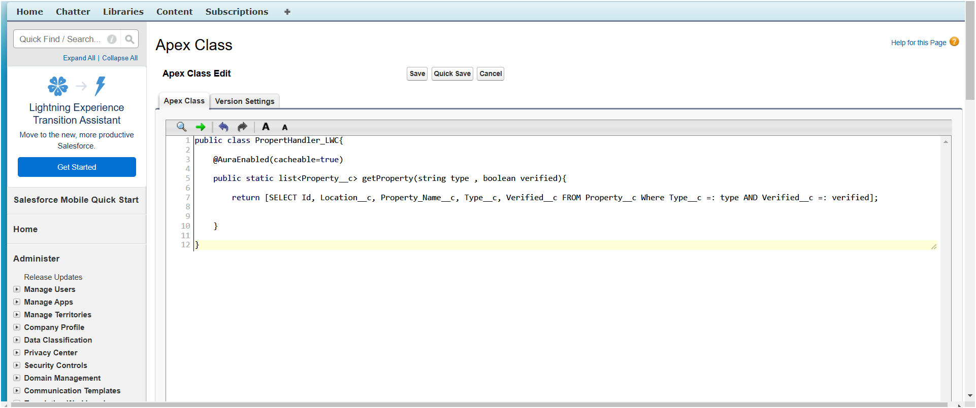

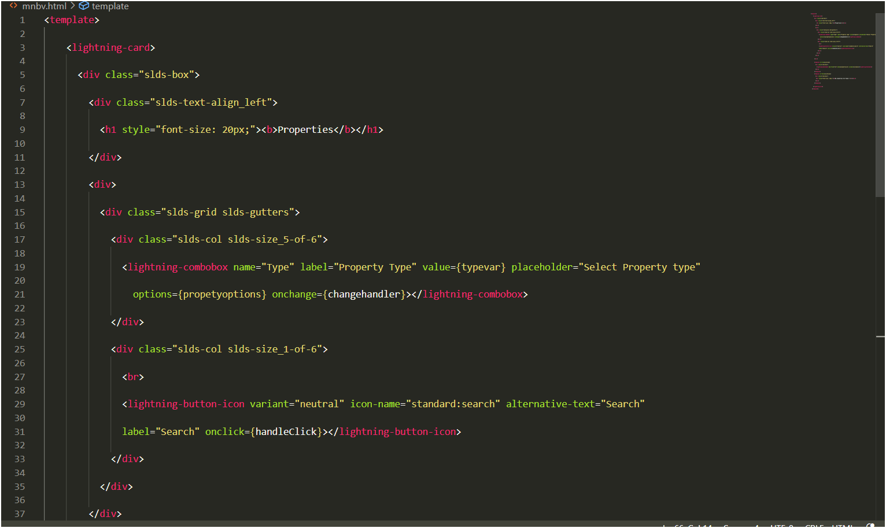

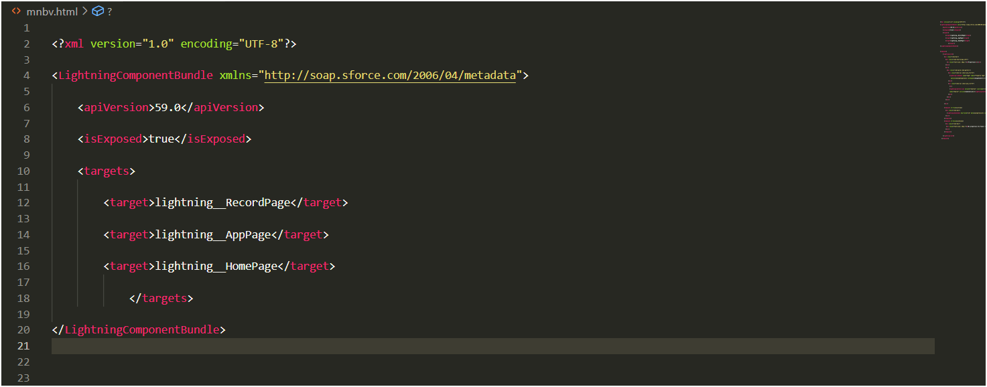

▪

**Key Scenarios**

**1. Property Inquiry and Client Requirement Management**

* **Scenario:** Clients submit inquiries about available properties or specify their requirements for property searches.
* **Solution:** The CRM captures and organizes all client inquiries, storing preferences like location, budget, and property type. Automated workflows match client requirements to suitable properties, providing agents with recommendations for client follow-ups and reducing search time.

**2. Automated Property Listing and Approval Process**

* **Scenario:** Agents submit new property listings for review, which require approval before becoming available to clients.
* **Solution:** An automated approval process within the CRM handles new property listings, notifying agents when listings are approved or need revisions. This feature ensures only quality listings go live, streamlining review and maintaining listing standards.

**3. Appointment Scheduling for Property Viewings and Consultations**

* **Scenario:** Clients schedule appointments to view properties or discuss their property requirements with agents.
* **Solution:** The CRM’s scheduling functionality manages all appointment details, including initial booking, rescheduling, and status tracking (e.g., scheduled, completed). Agents can efficiently organize viewings and consultations, improving client experience and communication.

**4. Deal Tracking and Transaction Management**

* **Scenario:** Clients initiate property transactions that require continuous updates and document handling.
* **Solution:** The CRM captures each transaction from initiation to closure, providing a central place to track deal progress, manage documents, and notify clients of status updates. This enables smooth transaction management and reduces the chance of missed updates.

**5. Reporting and Analytics on Client Engagement and Property Performance**

* **Scenario:** Management needs insights into client engagement trends, property performance, and transaction progress to make strategic decisions.
* **Solution:** The CRM’s reporting and dashboard features generate real-time insights on metrics such as client inquiries, listing activity, and deal status. These analytics help the management team adjust strategies, forecast trends, and evaluate agent performance.

**Conclusion**

**Summary of Achievements:**

The Nanmudhalvan CRM implementation successfully addressed core operational needs in client management, property listing, and transaction processing, creating an efficient and client-focused real estate service.

1. **Enhanced Client Engagement and Satisfaction:**  
   The CRM enables seamless handling of client inquiries, property searches, and viewings, providing a personalized and responsive experience that drives higher client satisfaction and loyalty.
2. **Streamlined Property and Deal Management:**With automated property listings and deal tracking, the CRM reduces manual effort for agents, speeds up the approval process, and ensures transactions are organized and transparent.
3. **Data-Driven Decision Making:**Real-time reports and dashboards support management in making informed decisions, understanding client preferences, and optimizing property inventory based on market demand.
4. **Increased Operational Efficiency:**The CRM’s automation and centralized data structure allow agents to focus more on client service and relationship building, improving operational productivity.

Through these capabilities, the Nanmudhalvan CRM has positioned the business to manage client relationships, property listings, and deals more effectively, supporting growth and enhancing overall service quality.